Project Design Phase
Solution Architecture

Date | 02 July 2026
Team ID
Project Name | Sports Hall Booking System using Service Portal (ServiceNow)
Maximum Marks | 4 Marks

Solution Architecture:
- 1. The Design Paradigm (PaaS & Scoped Isolation)
- It theoretically explains why building this inside a ServiceNow Scoped Application Container is the optimal choice. It proves that isolating your sports tables (u_sports_hall_booking) prevents the application from breaking when the core ServiceNow platform undergoes global upgrades or patching cycles.
- 2. The 3-Tier Layer Separation
- It analyzes the system by separating it into three distinct theoretical layers:
- The Presentation Tier (Frontend UI): How the system handles asynchronous, single-page operations using an interactive AngularJS/Bootstrap web portal grid.
- The Application Tier (Core Logic Engine): How JavaScript Script Includes, synchronous Business Rules, and Flow Designer engines compute time slots, manage waitlists, and enforce business rules.
- The Data Tier (Relational Storage): How the database protects records using Access Control Lists (ACLs), role-based permissions, and Advanced High Availability (AHA) cloud data replication.
- 3. Core Technical Mechanisms
- It details the exact theoretical logic behind your most critical features:
- Concurrency Protection: The exact boundary-checking math algorithm (start_time < requested_end_time AND end_time > requested_start_time) used by the database to permanently prevent two users from double-booking the same court at the exact same fraction of a second.
- The Auto-Release Lifecycle Loop: A detailed behavioral lifecycle map explaining how background cron jobs scan active data blocks every 60 seconds to automatically release "no-show" slots after 15 minutes.
Example - Solution Architecture Diagram:

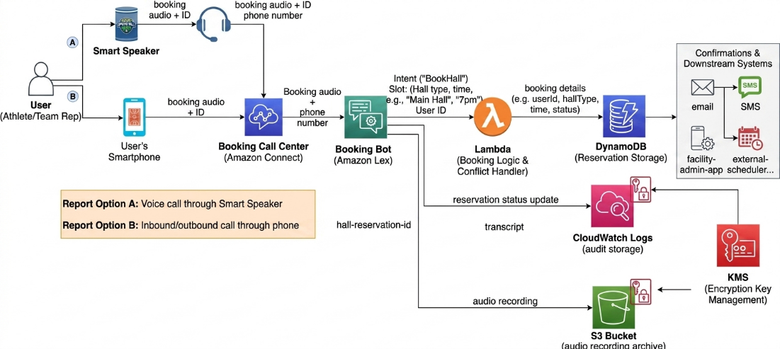
Reference link: AWS Lambda & DynamoDB Integration Architecture

